Port Alberni – Indigenous Territory Acknowledgement Video
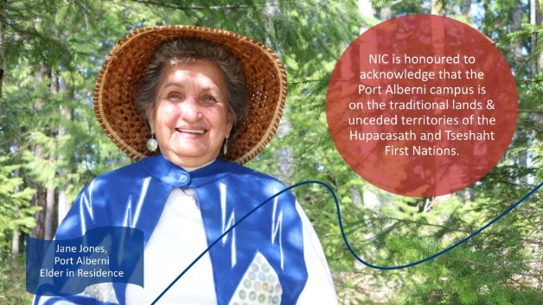
Instructions to Add/Embed to your Brightspace Course HTML Page
- In Brightspace already have a HTML page already set up with a HTML template and title. Create the HTML page via Course Builder, insert in proper file folder/module/topic and save to corresponding file folder in Manage Files via "destination".
- Put a title and an introductory text on the page like this:
Port Alberni Territory Acknowledgement Video
ƛ̓uum̓aaʔateʔicuu NIC respectfully acknowledges we operate within the unceded traditional territory of the Hupacasath and Tseshaht First Nations.
- If not done already, go to the Teach Anywhere Indigenous Territory Videos page and select the video you want. Underneath the image is a Word document with the embed code. This document. See code below.
- Copy the entire code from < (opening tag) to > (closing tag). Copy to your clipboard.
- In Brightspace, navigate to your HMTL page and put your cursor where you want the video.
- Select Insert Stuff icon (in the edit bar) > Enter Embed Code choice. Paste embed code.
- It will preview for you and then select INSERT blue button.
- Video shows up. SAVE and CLOSE the HTML page.
- Repeat by placing the cursor in your HMTL page to another location and repeating for another video.
NOTE: It is not advisable to add a video in any other way. It should sit on a Brightspace HTML page with a proper title and explanation about what it is and then the embedded video is able to be played.
Code to copy and paste in Brightspace via Insert Stuff > Enter Embed Code
<iframe id="kaltura_player" src="https://api.ca.kaltura.com/p/128/sp/12800/embedIframeJs/uiconf_id/23449900/partner_id/128?iframeembed=true&playerId=kaltura_player&entry_id=0_9p332nzv&flashvars[streamerType]=auto&amp;flashvars[localizationCode]=en&amp;flashvars[leadWithHTML5]=true&amp;flashvars[sideBarContainer.plugin]=true&amp;flashvars[sideBarContainer.position]=left&amp;flashvars[sideBarContainer.clickToClose]=true&amp;flashvars[chapters.plugin]=true&amp;flashvars[chapters.layout]=vertical&amp;flashvars[chapters.thumbnailRotator]=false&amp;flashvars[streamSelector.plugin]=true&amp;flashvars[EmbedPlayer.SpinnerTarget]=videoHolder&amp;flashvars[dualScreen.plugin]=true&amp;flashvars[hotspots.plugin]=1&amp;flashvars[Kaltura.addCrossoriginToIframe]=true&amp;&wid=0_pqnfu33a" width="608" height="402" allowfullscreen webkitallowfullscreen mozAllowFullScreen allow="autoplay *; fullscreen *; encrypted-media *" sandbox="allow-forms allow-same-origin allow-scripts allow-top-navigation allow-pointer-lock allow-popups allow-modals allow-orientation-lock allow-popups-to-escape-sandbox allow-presentation allow-top-navigation-by-user-activation" frameborder="0" title="Port Alberni- Territory Acknowledgement"></iframe>

